**Exchange rate’s relation to Income Inequality, Human Development and Life Expectancy**

Sayem Lincoln

[lincol45@msu.edu](mailto:lincol45@msu.edu)

Michigan State University

EC 499 Senior Seminar Economics Major

Professor Jeffery Woolridge

Fall 2020 Term Paper

**Abstract**

The research paper looks to answer the question - Does having a higher exchange rate per USD signify a better way of life? In order to, answer this question, the paper will analyze the relationships between income inequality measured by the Gini coefficient, Human Development index (HDI), Life Expectancy index, U.S. trade in goods, exports and imports (% of GDP), the official exchange rate per U.S. Dollar, and with the demographic of the country. The methodology consists of estimating regression models on a detailed panel dataset comprising of 20 Asian countries and covering 21 years (1998-2018). Initially, the paper sought to develop logit models and calculate Average Treatment Effects to analyze trade between countries and the United States and how that trade balance impacted the country’s exports and import (% of GDP), income inequality, human development and life expectancy. However, in pursuit of data for trade balance between the United States and the dataset countries, it was found that panel data regressions such as fixed and random effects regressions, with Hausman test and Breusch-Pagan Lagrange multiplier (LM) test would be better regressions and tests to analyze the data.

*See Table 2A in Appendix for List of Countries included in Dataset

**Exchange rate’s relation to Income Inequality, Human Development and Life Expectancy**

1. **Introduction**

One of the most important and controversial issues in the world economy is the

measurement of wealth of nations. Some such measure is needed for making consistent

comparisons of incomes across countries to identify those which have been more

economically successful than others

One of the most important and controversial issues in the world economy is the

measurement of wealth of nations. Some such measure is needed for making consistent

comparisons of incomes across countries to identify those which have been more

economically successful than others

One of the most important and controversial issues in the world economy is the

measurement of wealth of nations. Some such measure is needed for making consistent

comparisons of incomes across countries to identify those which have been more

economically successful than others

One of the most important and controversial issues in the world economy is the

measurement of wealth of nations. Some such measure is needed for making consistent

comparisons of incomes across countries to identify those which have been more

economically successful than others

One of the most important and controversial issues in the world economy is the

measurement of wealth of nations. Some such measure is needed for making consistent

comparisons of incomes across countries to identify those which have been more

economically successful than others

One of the most important and controversial issues in the world economy is the

measurement of wealth of nations. Some such measure is needed for making consistent

comparisons of incomes across countries to identify those which have been more

economically successful than others

One of the most important and controversial issues in the world economy is the

measurement of wealth of nations. Some such measure is needed for making consistent

comparisons of incomes across countries to identify those which have been more

economically successful than others

One of the most important and controversial issues in the world economy is the

measurement of wealth of nations. Some such measure is needed for making consistent

comparisons of incomes across countries to identify those which have been more

economically successful than others

One of the most important and controversial issues in the world economy is the

measurement of wealth of nations. Some such measure is needed for making consistent

comparisons of incomes across countries to identify those which have been more

economically successful than others

One of the most important and controversial issues in the world economy is the

measurement of wealth of nations. Some such measure is needed for making consistent

comparisons of incomes across countries to identify those which have been more

economically successful than others

One of the most important and controversial issues in the world economy is the

measurement of wealth of nations. Some such measure is needed for making consistent

comparisons of incomes across countries to identify those which have been more

economically successful than others

One of the most important and controversial issues in the world economy is the

measurement of wealth of nations. Some such measure is needed for making consistent

comparisons of incomes across countries to identify those which have been more

economically successful than others

One of the most significant and divisive topics in world economy is centered on the process of evaluating the wealth of a nation. One process of making this evaluation is by consistent comparisons of incomes across countries to identify those which have been more economically successful than others, and this process of comparison takes place when the currency of the country is evaluated, and this is done through the exchange rate. At the same time, does doing economically better signify that the population of the country in question gets to live a better life?

As in recent years, the global view and the structure of poverty classification has altered from a country with a poor population to a society with a divided socioeconomic class. An underprivileged country in the past was seen as a country with an entirely poor population, but in recent times that viewpoint has shifted, as now the majority class of the population signify the state the country is in and the wealth of the country. For some of these countries there are substantial population living a life of poverty, and for some other countries the opposite is happening. Countries with elevated inequality creates significant division within the socioeconomic class, hampering potential growth and economic success. The Gini index is used to measure the overall deviation of a country’s economy from a perfectly equal distribution of wealth across the population. And, the Human Development index (HDI) is a statistic composite index of life expectancy, education, and per capita income indicators, which are used to rank countries into four tiers of human development. Hence, by using these two indices a country’s wealth can be determined in regard to its socioeconomic state.

Additionally, the country’s wealth also depends on the amount of trading the country conducts with a developed nation, as this notion goes to indicate the productivity of the country. The trade of a country can be broken down to the number of exports and imports conducted with another nation, and how the trading of goods impacted the percentage of the country’s gross domestic product.

Furthermore, conducting international trade impacts the exchange rate of the country, as goods brought and sold are always done on one fixed currency, and that is the U.S. Dollar, and then the value of the country’s currency is evaluated against the U.S. Dollar, which goes on to show the exchange rate of the country’s currency.

This paper contributes to understanding the relationship between income inequality measured by the Gini coefficient, Human Development index (HDI), Life Expectancy index, U.S. trade in goods, exports and imports (% of GDP), the official exchange rate per U.S. Dollar, and with the demographic of the country. By doing so explore whether having a higher exchange rate per USD signify a better way of life.

1. **Literature Review**

A portion of the literature encompassing inequality pursues to comprehend the fundamental aspects that can predict income inequality throughout countries. Some studies try to investigate the relationship between poverty, growth, and inequality in developing nations, sometimes forming subsets of sample countries based on economic or political regimes. But there are other studies that takes a different route to highlight how population indicators - such as Gini coefficient, human development and life expectancy may be more precise markers of income inequality levels.

This following paper analyzes the relationship between poverty, growth, and inequality in developing nations and the poverty-reduction performance of the recent wave of global economic growth occurring since the early 1990s (Kwasi, Fosu 2016). The paper differentiates between numerous declining rates of poverty and the outcoming results - increasing and decreasing rates of income inequality. However, the paper acknowledges that generalities exist. For example, more than 75 percent of the countries exhibited declining income inequality, even though the declining levels of income inequality contributed to growth in income rather than redistribution of income within the country.

The following paper explores the relationship that impacts carbon emissions patterns and changes in economic growth, inequality, and poverty in Pakistan in the period 1980-2001, using a multivariate cointegration approach (Hassan, Zaman, & Gul 2015). The results showed a positive relationship between economic growth and income inequality and that is also seen in case of poverty and income inequality both in the short run and in the long run, the relationship holds true even when adding carbon emissions as a variable. However, the paper is constrained by the fact that it only concentrates on Pakistan.

This research paper takes a different approach, the paper uses a dynamic specification to estimate the impact of trade on within-country income inequality in a sample of 65 developing countries over the 1980-1999 period. Their results suggest that trade with high income countries worsen income distribution in developing countries, both through imports and exports (Meschi, Vivarelli 2009). Though their findings provide support to the hypothesis that technological differentials and the skill biased nature of new technologies may be important factors in shaping the distributive effects of trade.

This paper contributes to understanding the relationship between exchange rates and international trade by investigating the effect of exchange rate volatility and misalignment on international trade and by exploring whether exchange rate misalignment affect trade policy decisions, conducted on 100 countries, covering 10 years (2000-2009). The main findings of this paper can be summarized as follows. First, exchange rate volatility does not affect international trade except in the occurrence of currency unions and pegged exchange rates. That is, any relationship between the volatility and trade variables is most likely driven by the underlining long-term policy credibility provided by currency unions and pegged exchange rates rather than short-term volatility itself. The second finding is that exchange rate misalignments do affect international trade flows in a substantial manner. Currency undervaluation is found to promote exports and restrict imports and conversely in the case of overvaluation (Nicita, 2013).

From the literature overview, it can be seen that a direct correlation between exchange rate and income inequality and human development has not been formulated, as most of the literature reviewed formulates an implication, but the hypothesis resulting from the implication is not tested. This is what the paper intends to do – formulate a correlation between the different factors and evaluate the significance of the correlation.

1. **Data**

The variables used in the analysis includes the Gini index, Human Development index (HDI), Life Expectancy index, U.S. trade in goods, exports and imports (% of GDP), the official exchange rate per U.S. Dollar, and the demographic of the country.

The Gini index is a measurement of the deviation of the distribution of income among individuals or households within a country from a perfectly equal distribution. The dataset used for Gini coefficient in this paper is from the World Development Indicators database, a database curated by the World Bank organization. In this dataset the coefficient value of a country ranges from 0 that represents absolute equality, to 100 that represents absolute inequality.

The Human Development index (HDI) is a composite index measuring average achievement in three basic dimensions of human development — a long and healthy life, knowledge and a decent standard of living. The HDI is the geometric mean of the three-dimensional indices:

$$HDI={\left(I_{Health }∙I_{Education}∙I_{Income}\right)}^{\frac{1}{3}}$$

The dataset used for HDI is from the calculations made by the Human Development Report Office (HDRO) which is based on data collected from - United Nations Department of Economic and Social Affairs (UNDESA) (2019b), United Nations Educational, Scientific and Cultural Organization (UNESCO) Institute for Statistics (2019), United Nations Statistics Division (2019b), World Bank organization (2019a), Barro and Lee (2018) and IMF (2019).

Life expectancy index is calculated by using birth expressed as an index using a minimum value of 20 years and a maximum value of 85 years. These maximum and minimum values are fixed goalposts adopted in the 2014 Human Development report (HDR) released by the United Nations. The dataset used for Life expectancy index is from the calculations made by the Human Development Report Office (HDRO) which is based on life expectancy values from UNDESA United Nations Department of Economic and Social Affairs (2017a).

U.S. trade in goods dataset details the amount of goods traded by a country with the United States, the dataset details the trade balance conducted between a country and the United States. The dataset presents two trade balances - one is the total number of exports and the other is the total number of imports, between the country and the United States. All the values noted are in millions of U.S. dollars on a nominal basis, not seasonally adjusted. The data presented in this dataset is coming from the United States Census Bureau.

Exports and imports (% of GDP) is the sum of exports and imports of goods and services, expressed as a percentage of gross domestic product (GDP). It is a basic indicator of openness to foreign trade and economic integration and indicates the dependence of domestic producers on foreign demand (exports) and of domestic consumers and producers on foreign supply (imports), relative to the country’s economic size (GDP). This dataset is from the World Development Indicators database, collected by the World Bank organization.

The official exchange rate per U.S. Dollar is the rate at which the country’s currency will be exchanged, the base currency in this dataset for the exchange in the U.S. Dollar. This dataset was collected by the International Monetary Fund and International Financial Statistics and was distributed by the World Bank organization.

Demographic of the country is presented in a dataset that gives the population size of the country during that period of year. This dataset is from the World Development Indicators database, collected by the World Bank organization.

The seven variables are broken down into two groups, one called the Development Index and the other the Trade Index. This is done to calculate the correlation coefficients measurements between the two different sets of variables that are being used in this paper. The Development Index consists of Gini, HDI, Life Expectancy and the demographic of the country. The Trade Index consist of the exports and imports ( % of GDP), traded exports by the country with the United States, traded imports by the country with the United States, official exchange rate per U.S. Dollar and the demographic of the country. Additionally, correlation coefficients measurements will also be conducted for the Overall model.

For the regressions, the seven variables will be interacted and regressed in models consisting of multiple regression models with variable interactions, correlation models, panel data models – fixed effects (FE) and random effects.

**3a. Summary Table of all Variables**

The table below shows the summary statistics for all the variables used in the paper. The general amount of observations is total of 420. However, data for some variables are missing for certain countries, resulting in a lower observation count.

*See Appendix Table 2A for variable names’ labels.

|  |  |  |  |  |  |
| --- | --- | --- | --- | --- | --- |
| **Variable** | **Observations** | **Mean** | **Std. Dev.** | **Min**. | **Max.** |
| **Gini** | 112 | 36.52143 | 3.055328 | 31.6 | 41 |
| **HDI** | 420 | 0.7435167 | 0.1243749 | 0.44 | 0.939 |
| **LifeExp** | 420 | 0.83425 | 0.0858346 | 0.641 | 0.995 |
| **ExRate** | 420 | 1490.218 | 4439.18 | 1.249567 | 22602.05 |
| **ExpImp** | 216 | 109.8963 | 98.61787 | 19.8 | 442.6 |
| **TradeImp** | 420 | 15582.53 | 21794.2 | 37.51159 | 129997.2 |
| **TradeExp** | 420 | 35382.14 | 76486.64 | 11.8749 | 539243.1 |
| **Dem** | 420 | 1.87e+08 | 3.65e+08 | 319144 | 1.39e+09 |

**3b. Models and Econometric Technique**

**Gauss Markov Assumptions -**

To test the Gauss Markov Assumptions, three linear regression models will be constructed one for each of the indices that was constructed and one for the overall model for this paper.

Multiple regression for Trade Index-

1. $\hat{ExRate} ={\hat{β}}_{o }+$ $ExpImp∙\hat{β_{1}} +$*TradeImp $∙\hat{β_{2}} +TradeExp ∙\hat{β_{3}} + Dem ∙\hat{β_{4}} +$ $\hat{μ}$*

Interactive regression built on previous model-

1. $\hat{ExRate} ={\hat{β}}_{o }+$ $ExpImp∙\hat{β_{1}} +$*TradeImp $∙\hat{β_{2}} +TradeExp ∙\hat{β_{3}} + Dem ∙\hat{β_{4} }+ TradeImp ∙ ExpImp ∙\hat{β_{4}} + TradeExp ∙ ExpImp∙ \hat{β_{5}}$* + $\hat{μ}$

Model 2 tests the effects of interactions between the percentage of GDP made up from exports and imports with the trade balance of exports and imports the country has with the United States, while regressing against the Exchange rate of the country.

The regression for the Overall model –

1. $\hat{ExRate} ={\hat{β}}_{o }+ Gini∙\hat{β_{1}} +$*HDI $∙\hat{β_{2}} + LifeExp∙\hat{β_{3}} +$ $ExpImp∙\hat{β_{4}} +$ TradeImp $∙\hat{β_{5}} +TradeExp ∙\hat{β_{6}} + Dem ∙\hat{β_{7}} +$ $\hat{μ}$*

Interactive regression built on Overall model-

1. $\hat{ExRate} ={\hat{β}}_{o }+ Gini∙\hat{β_{1}} +$*HDI $∙\hat{β_{2}} + LifeExp∙\hat{β_{3}} +$ $ExpImp∙\hat{β_{4}} +$ TradeImp $∙\hat{β_{5}} +TradeExp ∙\hat{β_{6}} + Dem ∙\hat{β_{7}} +$ Gini $∙ExpImp∙\hat{β_{8}} + HDI ∙ ExpImp ∙\hat{β_{9}} + LifeExp ∙ ExpImp∙ \hat{β_{10}}+ \hat{μ}$*

Panel data fixed-effects (FE) regression for the Overall model -

${\hat{ExRate}}_{it}={\hat{β}}_{0}+{Gini}_{it}∙\hat{β_{1}} +{HDI}_{it}∙\hat{β_{2}} +{LifeExp}_{it}∙\hat{β_{3}} +{ExpImp}_{it}∙\hat{β_{4}} +{TradeImp}_{it}∙\hat{β_{5}} +{TracdeExp}_{it}∙\hat{β_{6}} +{Dem}_{it}∙\hat{β_{7}} +{\hat{μ}}_{it}$

Panel data random-effects regression for the Overall model -

${\hat{ExRate}}_{it}={\hat{β}}_{0}+{Gini}_{it}∙\hat{β_{1}} +{HDI}_{it}∙\hat{β_{2}} +{LifeExp}_{it}∙\hat{β_{3}} +{ExpImp}_{it}∙\hat{β_{4}} +{TradeImp}_{it}∙\hat{β_{5}} +{TracdeExp}_{it}∙\hat{β_{6}} +{Dem}_{it}∙\hat{β_{7}} +{\hat{μ}}_{it}+{\hat{E}}_{it}$

*See Appendix Table 2B for variable names’ labels.

Model 4 tests the effects of interactions between the Gini coefficient, Human Development Index (HDI), and Life Expectancy with the percentage of GDP made up from exports and imports, while regressing against the Exchange rate of the country. Here the model is testing how the percentage of GDP made up from exports and imports interacts with the Gini coefficient, Human Development Index and Life Expectancy; by doing so we can see how the change in GDP from exports and imports impact the people of the country and their living standards.

In Model 5, all the variables are analyzed in a panel data fixed-effects (FE) model to see the impact one variable has on another one, by doing so the relationship between predictor and outcome variables within an entity can be explored.In Model 6, all the variables are analyzed in a panel data random-effects model to see whether the undetected individual effect consists of any elements that are correlated with the regressors in the model. So, to see whether the difference across the entities any influence on the dependent variable the random- effects model is being used.

**Random sampling**

The data meets the random sampling assumption because the original simple regression and multiple regression models include 20 Asian countries; none of the countries chosen are from any specific region of Asia or from a fixed economic background. The dataset includes a diverse mix of countries. The variation in the dataset ensures the randomness of the sample and eliminates worries of bias in the sampling. For example, we have data ranging from Brunei Darussalam to Qatar, which shows that the counties in the dataset are scattered from across Asia, instead of being from one specific region.

**No perfect collinearity**

If a variable was perfectly collinear with another variable, an increase in one of the variables would result in a perfectly linear increase in the other. To examine correlation across the variables in the paper, three correlation coefficients measurements were carried out, between the independent variables in the – Development Index, Trade Index and for the Overall model. Some of the variables show a strong negative correlation with each other, but since none of the variables are correlated heavily with one another based on the measurements, so it can be assumed that there is no perfect collinearity among the independent variables.

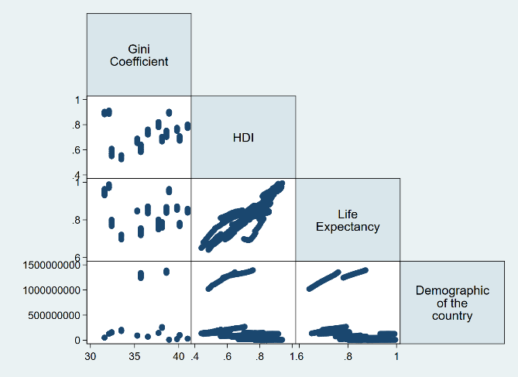

Figure 1 – Correlation coefficient measurement for Development Index

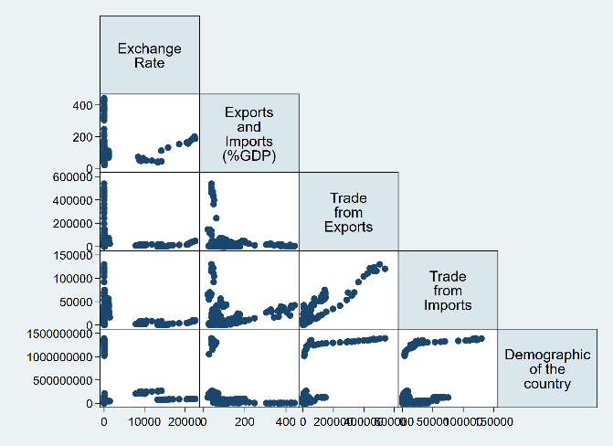

Figure 2 – Correlation coefficient measurement for Trade Index

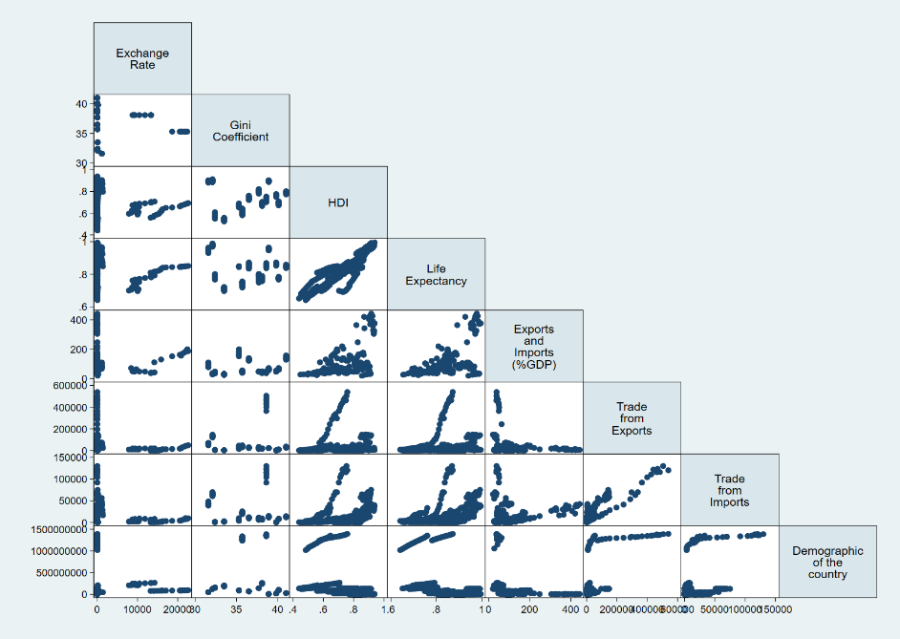

Figure 3 – Correlation coefficient measurement for the Overall model

**3c. Results**

The outcomes of all the regression are in *Table 1*. A brief overview of the equations–

Model 1: Multiple regression for Trade Index

Model 2: Multiple regression for Trade Index, ExpImp interacting with TradeExp and Trade Imp

Model 3: Multiple regression for Overall Model

Model 4: Multiple regression for Overall Model, ExpImp interacting with Gini, HDI and LifeExp

Model 5: Panel data fixed-effects (FE) multiple regression

Model 6: Panel data random effects multiple regression

*See table in next page for models’ results.

Table 1: Regression results for all Equations

|  |  |  |  |  |  |  |
| --- | --- | --- | --- | --- | --- | --- |
| **Variables** | **Model 1**  **(ExRate)** | **Model 2**  **(ExRate)** | **Model 3**  **(ExRate)** | **Model 4**  **(ExRate)** | **Model 5**  **(ExRate)** | **Model 6**  **(ExRate)** |
| **HDI** |  |  | 4317.2 | 101709.1*** | 14990.6 | 8823.2 |
|  |  |  | (4925.0) | (11403.2) | (14099.8) | (11560.0) |
| **LifeExp** |  |  | 8888.5 | -184760.4*** | 5859.1 | 11253.3 |
|  |  |  | (7472.7) | (24805.0) | (16622.6) | (14997.1) |
| **Dem** | -0.000000503 | 0.000000554 | 0.000000808 | -0.00000325*** | -0.00000118 | 0.00000107 |
|  | (0.000000461) | (0.000000421) | (0.000000851) | (0.000000933) | (0.00000777) | (0.00000384) |
| **ExpImp** | 10.35* | 24.91 | 67.13*** | -1491.8*** | 22.18* | 24.67** |
|  | (4.450) | (12.81) | (15.84) | (349.9) | (9.577) | (9.003) |
| **TradeImp** | -0.147*** | -0.0238 | -0.211** | 0.190** | -0.0519 | -0.0625 |
|  | (0.0426) | (0.0278) | (0.0657) | (0.0575) | (0.0345) | (0.0334) |
| **TradeExp** | 0.0368** | -0.0163 | 0.0515** | -0.0402** | 0.0106 | 0.0133 |
|  | (0.0119) | (0.0114) | (0.0153) | (0.0131) | (0.00979) | (0.00944) |
| **TradeImp·ExpImp** |  | -0.000919* |  |  |  |  |
|  |  | (0.000385) |  |  |  |  |
| **TradeExp·ExpImp** |  | 0.000690* |  |  |  |  |
|  |  | (0.000291) |  |  |  |  |
| **Gini** |  |  | -549.6** | 170.2 | 0 | -257.2 |
|  |  |  | (180.3) | (285.8) | (.) | (629.3) |
| **Gini·ExpImp** |  |  |  | 6.418 |  |  |
|  |  |  |  | (3.389) |  |  |
| **HDI·ExpImp** |  |  |  | -2243.0*** |  |  |
|  |  |  |  | (201.2) |  |  |
| **LifeExp·ExpImp** |  |  |  | 3470.0*** |  |  |
|  |  |  |  | (453.2) |  |  |
|  |  |  |  |  |  |  |
| **Constant** | 1896.3*** | 31.87 | 14783.2** | 74116.2*** | -14259.5* | -5572.0 |
|  | (412.0) | (879.0) | (4621.2) | (17403.3) | (6719.5) | (24339.9) |
| **Observations** | 216 | 216 | 112 | 112 | 112 | 112 |
| **R- Squared** | 0.086  Standard errors in parenthesis *p<0.05 **p<0.01 ***p<0.001 | 0.172 | 0.355 | 0.728 | 0.173  *See Appendix Table 2B for variable names’ labels. |  |

In Model 1(Trade Index) it can be seen that exchange rate is showcasing a heavy positive correlation to Exports and Imports (% of GDP), and is positively related to the exports made with the United States. However, exchange rate shows negative correlation with imports made with the United States. So, it can be seen that exchange rate of a country’s currency in per U.S. Dollar rises when exports are made with the United States but falls when the country is importing.

Model 2 interacts the variables that are in Model 1, from *Table 1* it can be seen the number of imports a country makes from the United States is negatively correlated to the exports and imports (% of GDP) similar to the findings in Model 1. The interactions solidify the findings of Model 1, which is also implied in the literature reviewed, as it can be seen from the increase of exports with the United States, the percentage of GDP being contributed by that export increases as the currency per U. S. Dollar rises; meaning the country is making more of its own currency shown by the positive correlation in the interaction. However, if the country imports more from the United States then the country loses more of its money, as now they will be paying more of its currency per U.S. Dollar for the import and that ends up taking away from the country’s GDP, shown by the negative correlation in the interaction.

Now taking the Overall model - Model 3, it can be seen that Gini coefficient is negatively related to the the exchange rate of the country’s currency per U.S. Dollar, and HDI and Life Expectancy are positively correlated. As for the rest of the variables – exports and imports (% of GDP), traded exports with the United States and traded imports from the United States follows the same patterns as those found in Model 1.

In Model 4, interactions were conducted between exports and imports (%of GDP) and the three development variables – Gini, HDI, Life Expectancy, this was done to showcase what a country in a worsen state would do. When Gini, and Life Expectancy were interacted with with exports and imports (% of GDP) the resulted correlation is positive. However, when exports and imports (% of GDP) interacted with HDI the relation is negative. This shows as income inequality rises (positive Gini coefficient) life expectancy falls in a country (negative coefficient) then the percentage of GDP coming from exports and imports contribute less (negative coefficient) to bettering the way of life, while the country’s currency valuation in the global economy falls as it increases per U.S. Dollar. So, in that situation with the rise in income inequality the country will do more imports and less exports with the United States; which can be witnessed in a country with a worsen socio-economic state, they import more goods from developed nations.

Model 5 and 6 are panel data models with results presented for both in *Table 1*, 5 is fixed-effects (FE) and 6 is random effects model. In these two models the regressions are running for every country in the dataset, across the panel data covering 21 years (1998-2018).

In Model 5, Gini coefficient was omitted by the model as the values of Gini coefficient across some years for some countries were the same and this was due to the regression being a fixed-effects (FE) regression. As FE does not take collinearity of the data for the variable across the years into account. From *Table 1*, it can be seen over the period of time human development and life expectancy in the country increases because of HDI and Life Expectancy being positively related, this is due to the country making more in its own currency from the increase in traded exports with the United States, shown by positive correlation. However, if the country does more imports then this will have a negative impact on the per U.S. Dollar country’s currency value as shown by the regression output for the FE model, as now the country has to pay more for imports in U.S. Dollar for the imported goods.

In Model 6 the panel data for random effects is tested and the random effects model is taking the Gini coefficient into account. From *Table 1* it can be seen every variable has a positive correlation to exchange rate except for trade from imports made with the United States and the Gini Coefficient. So, as the the currency evaluation in U.S. Dollar rises, Gini coefficient decreases in value, so this go on to state as the country makes more money in its own currency from exports the income inequality falls between the people of its country.

To decide which panel data regression best represented the Overall model for the paper between fixed or random effects, a Hausman test was ran. By doing the Hausman test it can be determined whether the unique errors ($μ_{i}$) are correlated with the regressors, the null hypothesis is they are not. After conducting the Hausman Test, it can be seen that the p-value equals 0.8740, which is greater than 0.05, so the random effects model is a better panel data regression for the paper’s Overall model.

*See Model 7 in Appendix for Hausman Test outputs

After conducting the Hausman Test, the Breusch-Pagan Lagrange multiplier (LM) test was used to see which regression would give the best outcome for the Overall model between the Model 4’s OLS regression and the Model 6’s panel data random effects regression. The null hypothesis in the LM test is that variances across entities is zero, meaning no significant difference across units (i.e. no panel effect). After running the LM test the p-value outputted was 0.00, so the null hypothesis is rejected and conclude that the random effects is the appropriate regression to present the overall model, because there is evidences of significant differences across countries and therefore OLS regression is not the best Overall model to present the outcome of this paper.

*See Model 8 in Appendix for Breusch-Pagan Lagrange multiplier (LM) Test outputs

**Conclusion**

From the outcomes of the regressions and tests, it can be concluded that the random effects regression is the best fit regression for the Overall model that the paper is presenting. As the random effects model takes significant differences across countries into account, as most countries will have different states of livelihood – distinct socio-economic state, various levels of income inequality (Gini coefficient) across countries and unique HDI level. Additionally, the trade balance of exports and imports with the United States will be different across countries this in turn will cause a variation in the exchange rate of each country’s currency per U.S. Dollar. So, to answer the question - Does having a higher exchange rate per USD signify a better way of life?

The dependency of a country’s socioeconomic development on the country’s exchange rate per U.S. Dollar is conditional, but having a higher exchange rate per U.S. Dollar does bring more inflow of their own currency when they are conducting exports and in turn increases the percentage of GDP contributed by exports and imports, so it does indicate a more progressive way of life.

**References**

Fosu, Augustin. “Growth, Inequality, and Poverty Reduction in Developing Countries: Recent

Global Evidence.” SSRN Electronic Journal, vol. 71, no. 2, May 2011, pp. 306–336., doi:10.2139/ssrn.1813968.

Hassan, Syeda Anam, et al. “The Relationship between Growth-Inequality-Poverty Triangle and

Environmental Degradation: Unveiling the Reality.” Arab Economic and Business

Journal, vol. 10, no. 1, June 2015, pp. 57–71., doi:10.1016/j.aebj.2014.05.007.

Meschi, Elena & Vivarelli, Marco. (2009). Trade and Income Inequality in Developing

Countries. World Development. 37. 287-302. 10.1016/j.worlddev.2008.06.002.

Nicita, Alessandro. (2013). Exchange rates, international trade and trade policies. International

Economics. s 135–136. 47–61. 10.1016/j.inteco.2013.10.003.

United Nation Development Programme, Human Development Reports, Income inequality,

measured by the Gini coefficient

http://hdr.undp.org/en/indicators/67106

United Nation Development Programme, Human Development Reports, Human

Development Index (HDI)

http://hdr.undp.org/en/indicators/137506

United Nation Development Programme, Human Development Reports, Life

expectancy index

http://hdr.undp.org/en/indicators/103206

United States Census Bureau, Foreign Trade, U.S. Trade in Goods by Country

https://www.census.gov/foreign-trade/balance/index.html

United Nation Development Programme, Human Development Reports,

Exports and imports (% of GDP)

http://hdr.undp.org/en/indicators/133206

World Development Indicators, The World Bank, Official exchange rate

(LCU per US$, period average)

https://data.worldbank.org/indicator/PA.NUS.FCRF

World Development Indicators, The World Bank, Population, total

https://data.worldbank.org/indicator/SP.POP.TOTL

**Appendix**

Table 4 – List of Countries included in Dataset

|  |  |  |  |
| --- | --- | --- | --- |
| Bangladesh | Indonesia | Philippines | Singapore |
| Brunei Darussalam | Israel | Qatar | Sri Lanka |
| China | Japan | Republic of Korea | Thailand |
| Hong Kong SAR, China | Malaysia | Russian Federation | United Arab Emirates |
| India | Pakistan | Saudi Arabia | Vietnam |

Table 5 – Variable names’ labels

HDI – Human Development Index

ExRate – Exchange Rate

LifeExp – Life Expectancy

TradeIM – Trade from Imports

TradeEX – Trade from Exports

Pop – Population of the country

AgeDib- Age Distribution

LitRate – Literacy Rate

Gini - Gini Coefficient

ExpImp - Exports and imports (% of GDP)